**IPT102 - Integrative Programming and Technologies 2**



**Section: SBIT-3J** **Group No: Group 1**

**Proposed Title: Ranzcent’s Pizza Online Ordering System**

**Leader:** Magante, Emil Joseph M.

**Members:**

1. Jonelas, Jeffrey Brian L.
2. Lacno, Bea gabrielle Angela B.
3. Magante, Emil Joseph M.
4. Maraya, Jhon Mark R.
5. Pabalate, Ranzcel Angelo L.
6. Ramos, Jeremy Yve
7. Revilla, John Vincent B.



**Description of the Proposed Software/System:**

The proposed project shall serve as an online voting system platform for every customer who wants to order pizza through the internet. The system aims to simplify the process of conducting orders via this system through an online medium. Since the manual ordering of orders through physical stores is easily prone to human errors, which means that many things could go wrong, with that in mind, the proponents have then concluded the potential of an online ordering system to make it easier for a pizza business to prosper.

***General Objective:***

The general objective of the ordering system is to provide an easy way for the users to make an order with this reliable system, giving customers a platform for them to order their favorite pizza remotely

***Specific Objectives:***

* To provide a system that will help to minimize the probability of human errors from happening.
* To create a system that will allow orders on a secured online platform.
* To provide a system that will improve the user experience by minimizing the number of clicks they do.
* To create a system that can handle numerous orders at one go.
* To develop a system that makes it easier for the owner to obtain feedback regarding their product.

**Scopes:**

* Human errors, such as billing mistakes, will be solved since the system will automatically compute the bill.
* Integrate the system to an internal SQL database to store all the necessary data regarding the pizza products and user accounts.
* The system will be able to cater to multiple amounts of pizza orders and the quantity of each to minimize the time it takes for customers to order.
* The customers’ orders will be gathered under a cart before checking out and finalizing the order.
* Provide an option for customers to leave a review for each pizza.

**Limitations/Delimitations:**

1. The system is only limited to processing orders and cannot cater any more bonus features for users, such as promo coupons and discounts.
2. There are no other payment methods available inside the system, like e-wallets or credit cards.
3. The customer and admin cannot directly talk with each other in real time within the system.
4. Customers cannot track their orders’ location after finalizing and submitting them.
5. The ordering system does not include an option for customized pizza orders.

______ Approved

______Disapproved

**Remarks:**

Hermar T. Garcia

**Professor**

**System Flowchart**

**USER:**

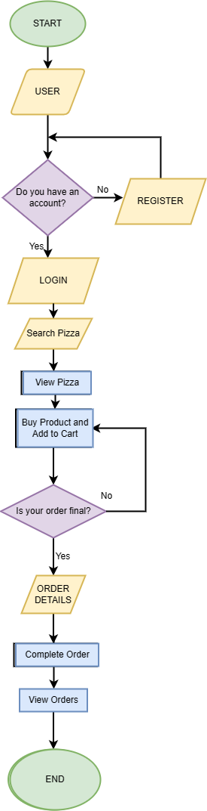

**ADMIN:**

